**Lovestuck Academy Documentation**

ふわふわ (Fuwa Fuwa) means fluffy and a feeling of warm happiness

Nicholas Chua Jay Ngan year 13

Alpha 2 footage https://www.youtube.com/watch?v=0D1orIK3Clw

**3.7**

**Aim**

Create a game in the genre of visual novel and dating simulator.

**Game Flow**

Tests

|  |  |  |  |  |
| --- | --- | --- | --- | --- |
| **Expected Tests** | | | | |
| Area | Testing | Expectation | Problem/Bug | Solution |
|  |  |  |  |  |
| Menu | Confirm Newgame(save exists) | Opens the confirmation screen when there isn’t a save file |  |  |
|  |  |  |  |  |
| Text Display | Going to the next page by pressing 1 | The next page of text displays |  |  |
| Choice Event | Choosing given choices | The selected choice loading its corresponding event. |  |  |
|  |  |  |  |  |
| “Introduction” Scene | Navigation | By pressing 1 or 2 the user can progress through the scene until the end where it loads the “FirstDay” scene. | Does not load the “FirstDay” scene at the end. | Deletes an uneccessary method that caused an issue which stops the scene from loading. |
| “First Day” Scene | Playing through a scene | Scene progresses to a choice event and then ends after the selected event runs its course | Text is skipped | Set the choice event to trigger at the right page. |
|  | Playing through a scene | Scene progresses to a choice event and then ends after the selected event runs its course |  |  |
| “First Day” Scene | Playing through a scene. | Changes scene when the player reaches the end of the scene. | "index was outside of bounds of array" error appears | Write code preventing the "index was outside of bounds of array" error |
| Code preventing "index was outside of bounds of array" error | Getting to the end of the text array and going one step further. | No error message occurs and scene changes. | Error message still appears. | Add -1 to the condition codes to account for the 0 elements. |
| “First Day” Scene | Choosing the 4th option. | Goes into the 4th event. | Goes into the 1st event | Set the element where the event trigger happens to element 10 and set a delay to prevent a key press from triggering twice. |
| “First Day” Scene | Choosing the 4th option. | Goes into the 4th event. | Goes into the 1st event | Rework the system: eliminating bools and changing the method to work with array length instead. |
| “First Day” Scene | Choosing the 4th option. | Goes into the 4th event. |  |  |
| Homeroom | Choice text display. | Text changes based on bools in “Save” | NullReferenceException object not set to an instance of an object.  Nothing displayed. |  |
| Homeroom | 4) Keep to yourself | Goes into the classes event | Nothing happens | Write code for the option. |
| Homeroom | 4) Keep to yourself | Goes into the classes event |  |  |
| Image System Text | Progress through a scene. | Images change as the page number reaches the set points. | NullReferenceException object not set to an instance of an object.  All images are displayed at once | Fixed and added references to the correct places. |
| Image System Text | Progress through a scene. | Images change as the page number reaches the set points. |  |  |
| Image System Text | Progress through a scene | Images are displayed and change when they are set to. | Images cover the text box. | Make the image system a child of the text system so it no longer covers it. |
| Classes | Enter the “Classes” scene. | A random remark is chosen from the array and displayed. |  |  |
| Classes | Go to the next scene | Goes the next scene which is determined by the “lunchCount” int from the save file. |  |  |
| Image System Choice | Choose events | Loads the correct images for each event. | Starting event images do not disappear | Make it so that starting events disappear when the first chosen event image loads |
| Image System Choice | Choose events | Loads the correct images for each event. |  |  |
| Elevator | Press 2 | Loads the “Club1st” scene | Loads “ShiroMeet” scene instead. | Change the name of the scene loaded from “ShiroMeet” to “Club1st” |
| Elevator | Press 1 | Loads the “Home” scene | Doesn’t load it. | Write the code that wasn’t previously there to load the “Home” scene. |
| “EloraMeet” | Progress through the scene, choosing the 2nd choice. | Loads the correct text from the 2nd array and displays the images corresponding to it. | Can’t end the scene as the text is stuck on the 2nd last page. | Fix an if condition that works to stop errors for the choice event but stops the scene from ending. |
| Classes(updated version) | Press space | Chooses a random page from the array. | Nothing happens | Added a missing “page =” in the code. |
| Save | Exit to the menu and use continue. | Goes to the beginning of the last scene you were on. | Goes to the “Introduction” scene. | Have a different script execute the method to load the last scene. Save the name of the scene constantly to avoid and Unity mishaps. |
| Save | Exit to the menu and use continue. | Goes to the beginning of the last scene you were on. |  |  |
| **Boundary Tests** | | | | |
|  |  |  |  |  |
| Choice Event | Selecting the highest number choice | It loads the corresponding event. |  |  |
| Image System Text | Set certain images to trigger at a page number is less than 0 so that they don’t appear. | The images not supposed to appear don’t and the scene progress normally |  |  |
| Image System Text | Set certain images to trigger at a page bigger than the maximum page number. | The images not supposed to appear don’t and the scene progress normally |  |  |
| Pressing Space | Hold the space bar | Goes to the next page once |  |  |
| **Unexpected Tests** | | | | |
|  |  |  |  |  |
| Choice Event | Trying to select choices not given by pressing 3 and 4 when there are only 2 choices | Nothing happens |  |  |
| Image System Text | Set all images to trigger at the same scene | The only images that appear are “Back3” and “Girl6” |  |  |
| Image System Text | Set images designed to appear later on first and the first images to appear later | Later images do not disappear when the first images appear. |  |  |
| Image System Text | Go through a scene normally | The correct images load. | Text boxes and other UI are covered by the image system canvas. | Make the image system a child of the main UI canvas. |
| Affection Point System | Repeatedly exiting and entering a scene which starts it all over from the beginning. | This allows the player to repeatedly farm affection points as affection points are given at the start of the scene for text only events and when a choice is made for choice events. |  | Set it so that affection points are only awarded just as the scene changes |
| Pressing space | Press the space bar rapidly | Goes to the next page multiple times |  |  |
| Pressing space + choice | Press the space bar during a choice event | Nothing happens |  |  |

**Credits**

Programming and Sprites by Nicholas Chua

**3.2**

**Planning** was done in LovestuckAcademy.docx

**Project management** was done with Trello

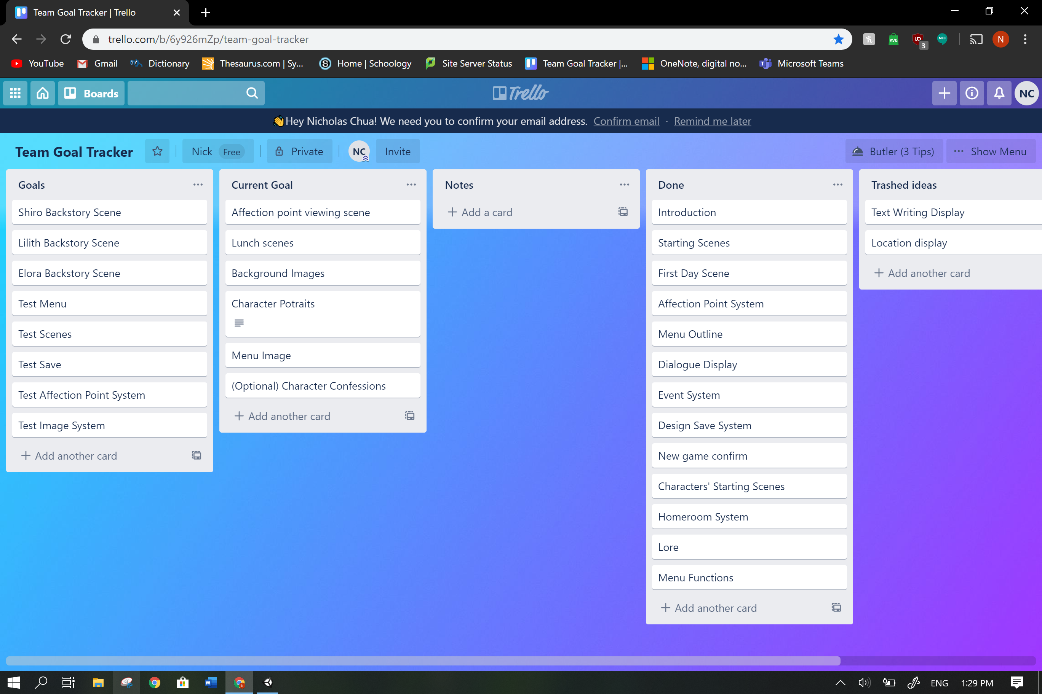

Text system was initially made using a queue and array based off of the system from <https://www.youtube.com/watch?v=_nRzoTzeyxU> where a queue would load elements form and array and then be dequeued to return the text to the text display but the system could not function as so was replaced with another system built solely on arrays which is simpler and functions well.

**Feedback and Changes**

“You could probably reverse google search the photos.” **-Veteran Coder Aidan**

To avoid the potential issue of getting sued, I have edited the background sprites to less resemble the original photos they were based off of and changed things to fit the in-game lore.

|  |  |  |
| --- | --- | --- |
| Original | Pixelized | Edited |
| Japanese Classroom" Model #AD#3D Classroom#Japanese#quot#Interior ... |  |  |

Original from <https://www.assetstore.unity3d.com/#!/content/71392?aid=1101l3b93&pubref=3D>

“Maybe you could make a lore page for it like ‘Mass Effect’.” **-Veteran Coder Aidan**

A lore page was added to the menu and expanded upon.

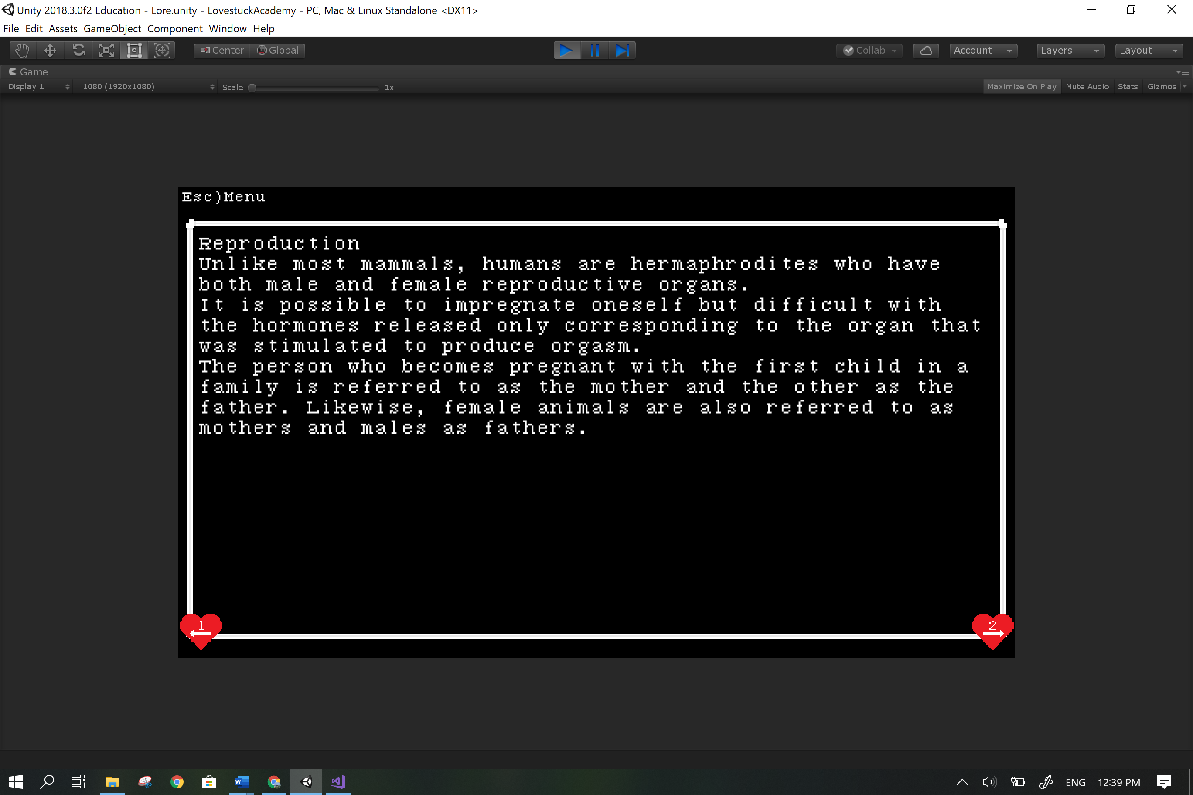

“The background images don’t scale well for 1980x1080.” **-Man of Taste Fred**

“I went to character affection menu and I couldn’t get back to main menu.” **-Man of Taste Fred**

Wrote code to return to the menu by pressing the esc key.

“What’s the next button for the text, Spacebar? 1?” **-Man of Taste Fred**

Overhaul the system to progress with space instead of one which means removing all the hearts with one on them, adding the instruction at the beginning and altering most scripts as well as retesting it.

“I CAN’T KEEP TO MYSELF WRYYYY.” (context = option in the game) **-Man of Taste Fred**

Code for the option did not exist at the time and so it was written.

“Ketchup girl is also bugged’” **-Man of Taste Fred**

Made the image system a child of the text system so that images no longer covers the text boxes.

“Flow feels weird.” **-Myself**

Added text in between scenes to ease the flow.

**Relevant implications**

**Social:**

While the nature of the game as a dating simulator might create unrealistic expectations in relationships given the speed at which the heroines get attached to the character, it is expected for the user to distinguish between game and reality when making decisions; therefore I as the creator am not in any way responsible for any actions the user takes under the influence of the game.

Cultural: Nothing in the game should offend any and all cultures and religions but if anything does it was never intended to.

**Legal/ Intellectual property:**

Use of the program is completely legal, the user will not break any laws using the program.

Users are free to show footage of the game and borrow assets but must credit me for the sprites and cannot say it is their own work.

All character sprites were drawn by me and bear little to no resemblance to the things I based them off so it would be impossible to copyright claim them.

Background sprites were inspired by real images and designs.

All scripts in the “scripts” folder were written by me except for the referenced code by Josh Browne and Aidan Diprose.

The free for commercial use font was ‘**7:12 Serif Font’** by Christian Munk <https://christianmunk.1001fonts.com/>

**Ethical:**

Privacy:

The game does not ask for any personal information from the user except for their name. The user is not required to give their name but if they do so it is only used in the game for the user’s enjoyment and emersion. The game has no way of recording anything on your computer or through it (cameras or microphones).

**Accessibility:**

Usability/Functionality: The game is meant to be played for recreational use, it is the user’s opinion on how well it carries out it’s purpose but it functions as intended with no observed bugs remaining and improved after user feedback.

**Aesthetics:**

The pixel style of the game gives it a retro feel.

**Sustainability and Future proofing:**

The code is extensively commented and structured so that all methods and variables are easily understood by whoever wishes to maintain the code. Comments will detail the function of the code and the structure ensures a smooth flow of information.

**End-user considerations:**

The game is very simple and intuitive with very little mechanics and complexity that even a 5 year old could understand how to play the game in a matter of seconds. The controls are always shown and is explained at the start of the game.

**Health and safety:**

The game is short but through repeated playthroughs over long periods of time (3 hours or more) the user might suffer from the following conditions:

* sore eyes
* sore wrists
* neck pain
* back pain

The user is also advised not to stare too closely at the screen as that will be bad for their eyes.

**I am not in anyway responsible for the problems stated above.**